Network Basics

**What’s a Network?**

A computer **network** is a collection of computers, servers, network devices, peripherals(çevre bilimleri), or other devices connected to one another to share data. It doesn't matter whether the network contains two or thousands of machines; the concept is essentially the same. The devices on a network may be linked through cables, telephone lines, radio waves, or satellites.

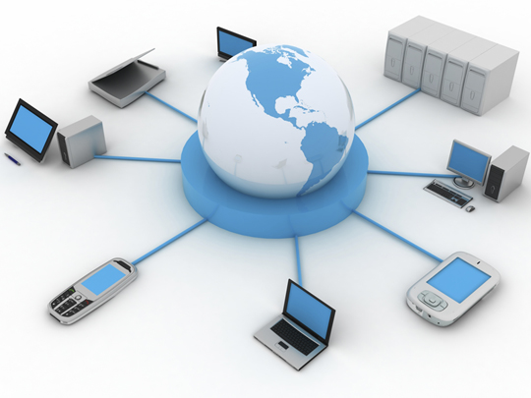

**A network illustration**

A network provides services to its users. In the past, these services have included access to shared files, folders, printers, and applications (email, database, etc.). Modern networks provide more distinct services, including web applications, voice over IP (VoIP), and multimedia conferencing.

Networks of different sizes are classified in different ways. A network in a single location is often called a **Local Area Network (LAN)**. This definition includes many different types and sizes of networks though. It can include both household networks with a couple of computers and enterprise networks with hundreds of servers and thousands of computers.

Networks in different geographic locations but with shared links are called **Wide Area Networks (WAN).**

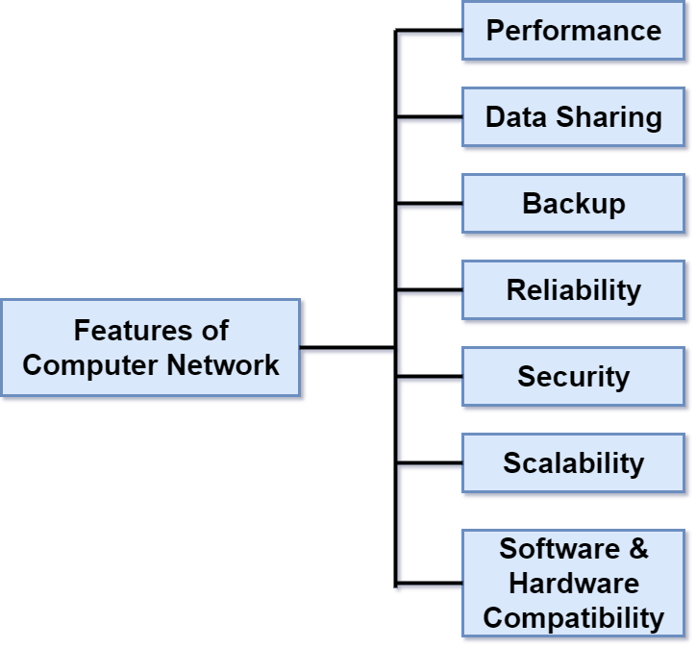

**Features of networks**

A computer network has the following features:

* **Performance:** Performance of a computer network is measured in terms of response time. On an efficient network, the response time of transmitted and received data from one device to another is minimal.
* **Data Sharing:** It is one of the main reasons why we use a computer network between different systems.
* **Backup:** A computer network must backup all the shared data, and keep that data on servers in order to recover the data faster in case of failures.
* **Reliability:** There should not be any failure in the network, but if it occurs the recovery from failure should be fast.
* **Security:** A computer network should be secure so that the data exchanged over a network should be safe from unauthorized access. Also, the transmitted data should be received without any loss.
* **Scalability:** A computer network should be scalable means adding new devices to the already existing computer network should always be possible.
* **Software and hardware compatibility:** A computer network must not limit all the computers to use the same software and hardware, instead, it should allow the users to use different software and hardware configurations on the network without any compatibility issues.

Q: What is a Computer Network?  
A: A computer network is a connection network between two or more nodes(düğüm) using [Physical Media](https://lms.clarusway.com/mod/lesson/view.php?id=1839) Links viz.(yani), cable, or wireless to exchange data over pre-configured services and Protocols. A computer network is a collective result of – Electrical Engineering, Computer Science, Telecommunication, Computer Engineering, and Information Technology involving their theoretical as well as practical aspects into action. The most widely used Computer Network of Today is the Internet which supports the World Wide Web (WWW).

 - Interview Q&A

**Local Area Network (LAN)**

Just as the name implies, a **local area network (LAN)** is usually restricted to spanning a particular geographic location such as an office building, a single department within a corporate office, or even a home office. Due to the technological advances, we’re almost free from the restrictions forced by both the size and the distance coverage of LANs.

To easily manage the networks, it’s a good idea to split LANs according to the department divisions. For example, we can create a LAN for *Accounting*, and another for *Marketing*. The figure shows two separate LANs.

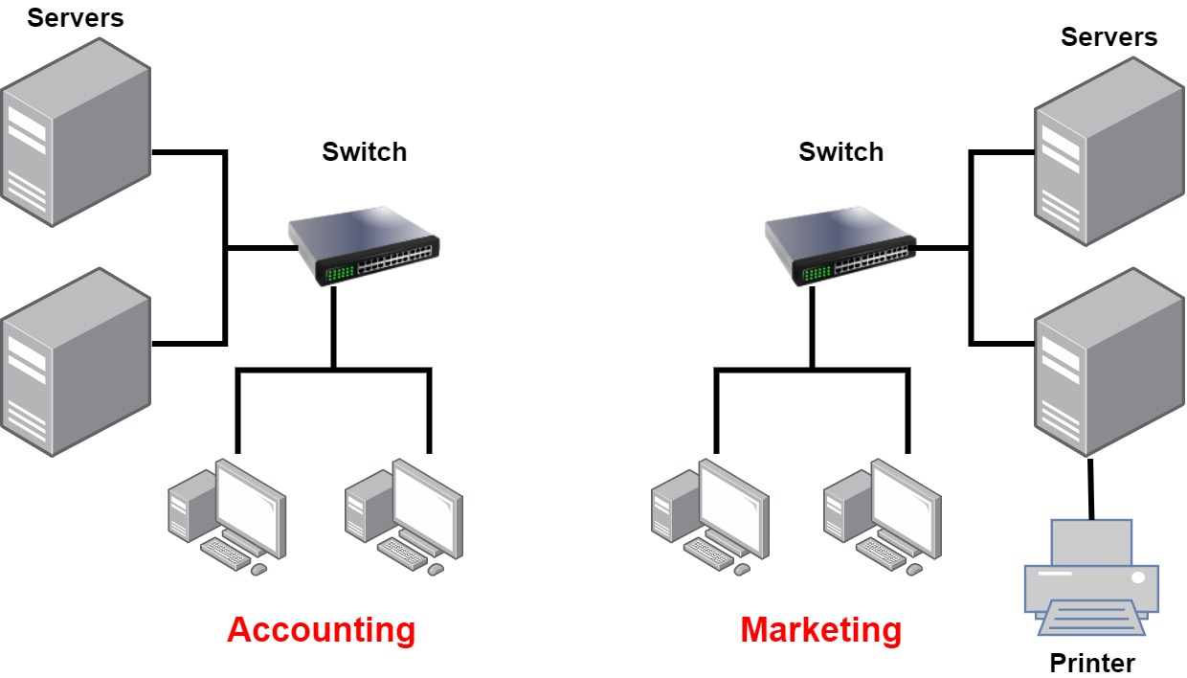

**Two separate LANs**

In the above figure, there are two LANs: Accounting and Marketing. Any device connected to the Marketing LAN can access the resources inside the Marketing LAN—in this case, the servers and printer. There are two problems with this:

* One must be physically connected to the LAN to get the resources from it.
* Nobody can connect from one LAN to another.

This is a typical network issue that’s easily fixed by using a device called **router** to connect the two LANs, as shown below.

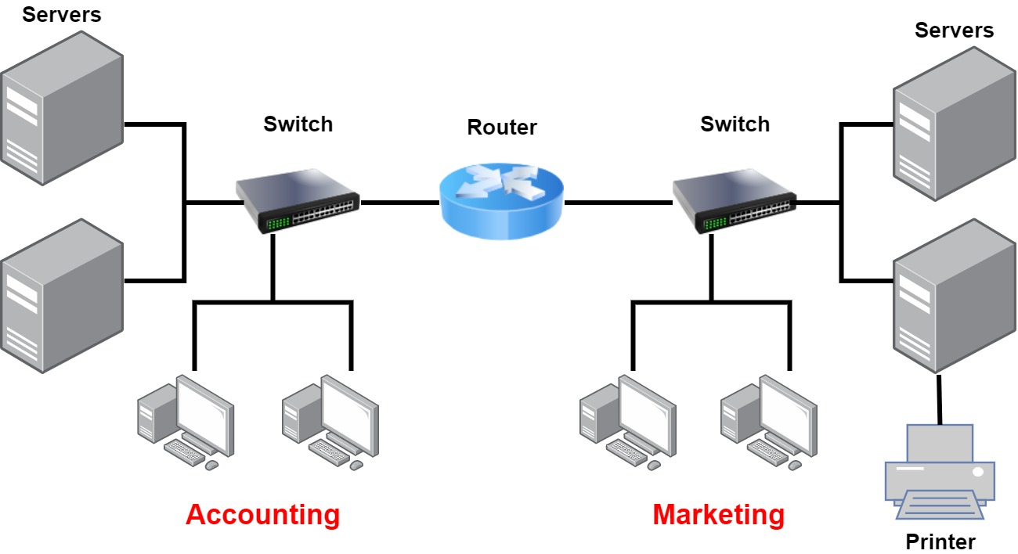

**A network with two LANs**

And the problem is solved!

The devices *switch* and *router* will be explained in detail in the following sections.

Q: Explain what is LAN?  
A: A LAN or Local Area Network is the network between devices that are located within a small physical location. It can be either wireless or wired. One LAN differs from another based on the following factors:  
**Topology:** The arrangement of nodes within the network  
**Protocol:** Refer to the rules for the transfer of data  
**Media:** These devices can be connected using optic fibers, twisted-pair wires, etc.

- Interview Q&A

**Common Network Components**

**Node, Stations, and Hosts:** A **node** is any device that can connect to a network. The term **node** can be used to describe *endpoint devices*, such as *computers, laptops, servers, IP phones, smartphones, or printers*, and *connecting or forwarding devices*, such as *switches* and *routers*. A **node** on a wireless network is often called a *station*.

The term **host** is often used in *TCP/IP networking* to mean an *end system device*, such as a *computer*, with a unique IP address on the network.

**Workstations:** Workstation is a client **machine** used to deploy an **application** or **server**. They are usually powerful **computers** that have more than one CPU and its resources are available to other users on the network. Workstations are often equipped with systems for end-users to use daily.

**Servers:** Servers are also powerful **computers**. They are “at the service” of the network and run specialized software known as the network operating system to maintain and control the network. Servers are highly specialized and handle important labor-intensive jobs. In order to get better performance, a single task is often assigned to a dedicated server. Here’s a list of common dedicated servers:

* **File Server** - Stores and manages files
* **Mail Server** - It's the network’s post office; handles email functions
* **Print Server** - Manages printers on the network
* **Web Server** - Manages web-based activities by running Hypertext Transfer Protocol (HTTP) for storing web content and accessing web pages
* **Application Server** - Manages network applications
* **Telephony Server** - Handles the call center and call routing
* **Proxy Server** - Handles tasks in the place of other machines on the network, particularly an internet connection.

Whether servers are designated for simple or complex network tasks, they can maintain the network’s data integrity by backing up the network’s software and providing redundant(gereksiz) hardware (for fault tolerance).

In the below figure, you can see a network topology consists of workstations and servers. Also notice that the hosts can access the servers across the network, which is the general idea of having a network!

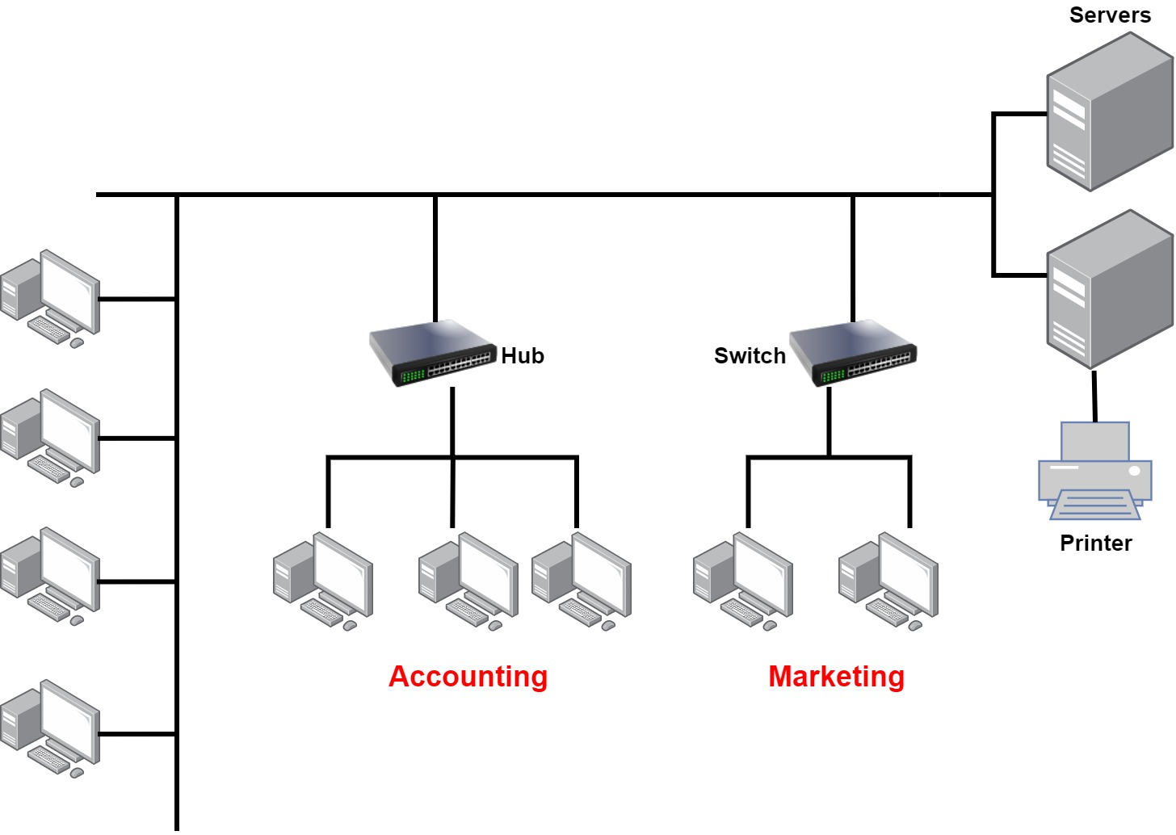

**A classic network structure**

**Transmission Media:** A link between network nodes is created using some form of transmission media like cables, or radio waves.

**Local Network Devices, Segments, and Backbones:** Relatively few networks are established to connect the hosts directly. Instead of direct links among them, each host is connected to a central node, such as a **switch** or **wireless access point**. The central node provides a forwarding function, that is, receives the data from one node and re-transmits it to the others.

A central device such as a **switch** implies that the connected nodes are part of the same physical network and use the same type of transmission media. The term **switching** is used for this forwarding function taking place within the same physical network. The addresses of interfaces within the same network are described as **local addresses**.

The term **segment** can be used to refer to a specific physical region of a network, though the scope of a segment depends on the exact technology in use. One typical usage now is to describe the link between a computer and a switch. Another usage is to refer to a region of the network where all the nodes use the same type of transmission media and have the same bandwidth.

A network is typically divided into segments either to cope with the physical restrictions of the network media used or to improve performance or to improve security (or all three). A **backbone** describes **a fast link** among other segments of a network. The backbone carries all the communications occurring between nodes in separate segments.

Q: What do you mean by a Node?  
A: The intersection point in a network is called a Node. Nodes can send or receive data/ information within a network. For example, if two computers are connected to form a network, there are 2 nodes in that network. Similarly, in the case of adding more computers, there will be more nodes and so on. It is not necessary for a node to be a computer, it can be any communication device such as a printer, servers, modems, etc..

- Interview Q&A

**Wide Area Network (WAN)**

Our own networks are called **LANs** (Local Area Network). We own and operate these networks. It’s called a **“local”** area network since all devices that make up the LAN are close to each other. Perhaps in one building or a few buildings close to each other (called a **campus**).

When we need to access other remote networks or give others access to our LAN, we need a **WAN (Wide Area Network)**. As the name implies, WANs cover *large geographical areas*. This could be a network between two cities or as large as the **Internet**.

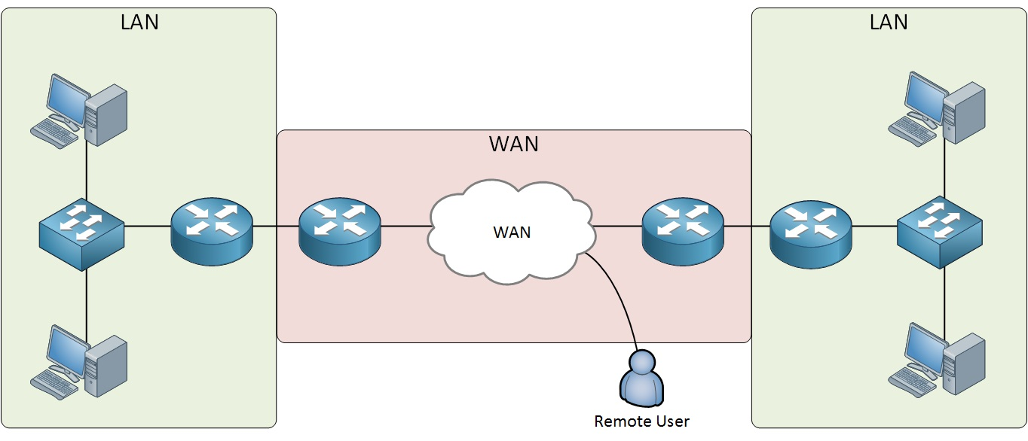

On the **LAN**, the dominant protocol that we use is **Ethernet**. For **WAN**, there are dozens of technologies and protocols we can choose from.

Below is the list of some differences between WAN and LANs:

* WANs usually need a router.
* WANs span larger geographic areas and/or can link diverse locations.
* WANs are usually slower.
* We can choose when and how long we connect to a WAN. A LAN is all or nothing—our workstation is connected to it either permanently or not at all.
* WANs can utilize either private or public data transport media such as phone lines.

We get the word Internet from the term internetwork. An internetwork is a type of LAN and/or WAN that connects a bunch of networks or intranets. In an internetwork, hosts still use hardware addresses to communicate with other hosts on the same LAN. However, they use logical addresses (IP addresses) to communicate with hosts on a different LAN. And routers are the devices that make this possible.

Q: What is WAN?  
A: WAN stands for Wide Area Network. It is an interconnection of computers and devices that are geographically dispersed. It connects networks that are located in different regions and countries.

- Interview Q&A

**Physical Network Topologies**

**Physical Network Topologies**

Network topology is the arrangement of the various nodes of a computer network. Essentially, it is the topological structure of a network and may be depicted **physically** or **logically** which are the two basic categories of network topologies.

The shape of the cabling layout used to link devices is called the **physical topology** of the network. This refers to the *layout of cabling, the locations of nodes*, *the interconnections between the nodes* and *the cabling*. The physical topology of a network is determined by:

* the capabilities of the network access devices and media,
* the level of control or fault tolerance desired,
* the cost associated with cabling or telecommunications circuits.

In opposition to the *Physical Topology*, the **logical topology** is the way that the *signals act on the network media*, or the *way that the data passes through the network* from one device to the next without regard to the physical interconnection of the devices.

**💡Tip:**

* A network’s logical topology is not necessarily the same as its physical topology.

The logical topologies are generally determined by network protocols as opposed to being determined by the physical layout of cables, wires, and network devices or by the flow of the electrical signals. In many cases, the paths that the electrical signals travel among the nodes may closely match the logical flow of data. That is why, the terms *logical topology* and *signal topology* can be interchangeably used.

Here’s a list of the topologies mostly used nowadays:

* Bus
* Star
* Ring
* Mesh
* Tree
* Point-to-point
* Point-to-multipoint
* Hybrid

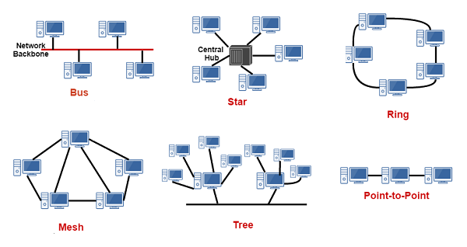

**Physical network topologies**

Q: What do you mean by network topology?

A: Network topology specifies the layout of a computer network. It shows how devices and cables are connected to each other. Some types of topologies are: Bus, Star, Ring, Mesh, etc.

- Interview Q&A

**Bus Topology**

A bus topology consists of a single cable ( the *bus* ) with a terminator at each end. All nodes (file server, workstations, and peripherals) are connected to this cable. The signal travels down the bus in both directions from the source and is received by all nodes connected to the cable. The bus is terminated at both ends of the cable to absorb the signal when it has passed all connected devices.

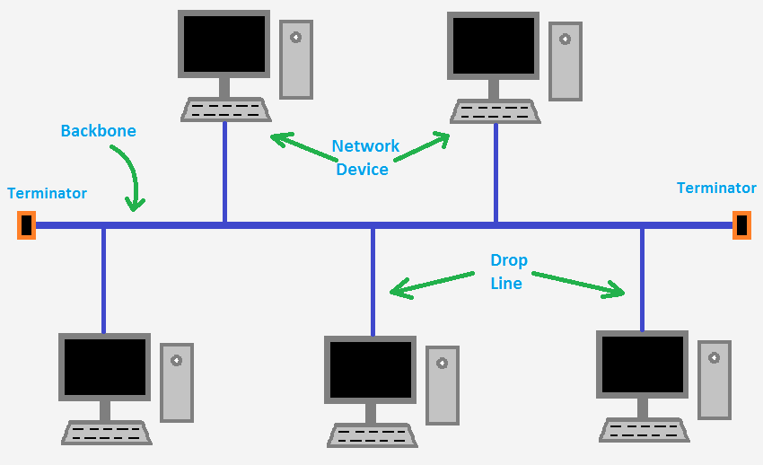

**The bus topology**

This type of physical bus topology is no longer in widespread use. Bus networks are comparatively difficult to reconfigure (adding or removing nodes can disrupt the whole network), impose limitations on the maximum number of nodes on a segment of cable, and are difficult to troubleshoot (a cable fault could be anywhere on the segment of cable). Perhaps most importantly, a fault anywhere in the cable means that all nodes will be unable to communicate.

The logical bus topology, however, remains the basis of most local networks.

**Advantages of bus topology:**  
1. Easy installation, each cable needs to be connected with the backbone cable.  
2. Fewer cables required than mesh and star topology (We'll see these topologies in the following lessons)

**Disadvantages of bus topology:**  
1. Difficulty in fault detection.  
2. Not scalable as there is a limit of how many nodes can be connected.

**Star Topology**

In star topology, every node (computer workstation or any other peripheral) is connected to a central node called **hub** or **switch**. The network does not necessarily have to resemble a star to be classified as a star network, but all of the nodes on the network must be connected to one central device. All traffic that traverses the network passes through the central hub.

The star topology is the most widely used physical topology. It is easy to reconfigure and easy to troubleshoot because all data goes through a central point, which can be used to monitor and manage the network. Faults are automatically isolated to the node (network card), or the hub, switch, or router at the center of the star.

**Advantages of Star topology:**  
1. Less expensive because each device only needs one I/O port and needs to be connected with a hub with one link.  
2. Easier to install.  
3. Less amount of cables required because each device needs to be connected with the hub only.  
4. Robust(güçlü), if one link fails, other links will work just fine.  
5. Easy fault detection because the link can be easily identified.

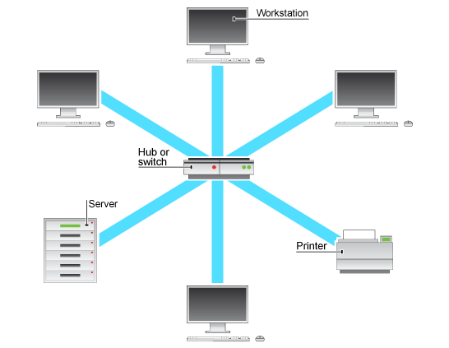

**Disadvantages of Star topology:**  
1. If the central node goes down every node goes down, none of the devices can work without the central node.  
2. The central node requires more resources and regular maintenance because it is the central system of star topology.

Q: Describe star topology  
A: Star topology consists of a central hub that connects the nodes. This is one of the easiest way to setup and maintain.

- Interview Q&A

Q: What is the disadvantage of a star topology?  
A: One major disadvantage of star topology is that once the central hub or switch damaged, the entire network becomes unusable.

- Interview Q&A

**Ring Topology**

A network topology is set up in a circular fashion in which data travels around the ring in one direction and each device on the right acts as a repeater to keep the signal strong as it travels. Each device incorporates a receiver for the incoming signal and a transmitter to send the data to the next device in the ring. If a device wants to send data to another device then it sends the data in **one direction,** if the received data is intended for other devices then it forwards this data until the intended device receives it.

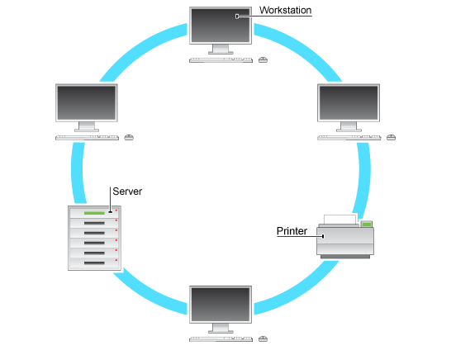

**The ring topology**

The physical ring topology is no longer used on LANs but it does remain as a feature of many WANs. Two ring systems (dual counter-rotating rings) can be used to provide fault tolerance. These dual rings allow the system to continue to operate if there is a failure in one ring.

**Advantages of Ring Topology:**  
1. Easy to install.  
2. Management is easier because to add or remove a device from the topology only requires changing just two links.

**Disadvantages of Ring Topology:**  
1. A link failure can fail the entire network as the signal will not travel ahead due to failure.  
2. Data traffic issues, since all the data is circulated in a ring.

Q: What are some drawbacks of implementing a ring topology?  
A: In case one workstation on the network suffers a malfunction, it can bring down the entire network. Another drawback is that when there are adjustments and reconfigurations needed to be performed on a particular part of the network, the entire network has to be temporarily brought down as well.

- Interview Q&A

**Mesh Topology**

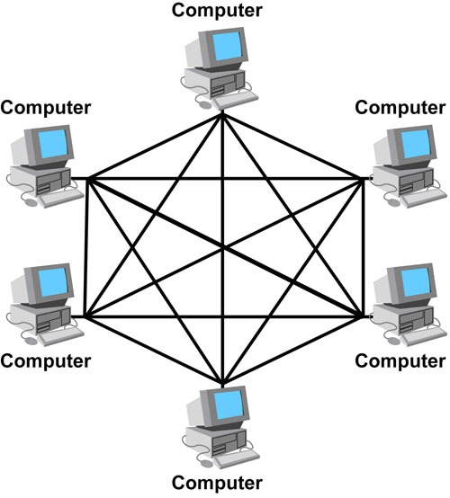**Mesh network topologies** are commonly used in **WANs**, especially public networks like the Internet. In theory, a mesh network requires that each device has a point-to-point link with every other device on the network (**fully connected**). This approach is normally impractical, however. The number of links required by a full mesh is expressed as n(n-1)/2, where "n" is the number of nodes. For example, a network of just 4 nodes would require 6 links, while a network of 40 nodes would need 780 links!

Consequently, often a "**hybrid**" approach is used with only the most important devices interconnected in the mesh, perhaps with extra links for fault tolerance and redundancy. In this case, the topology is referred to as a **partial mesh.**

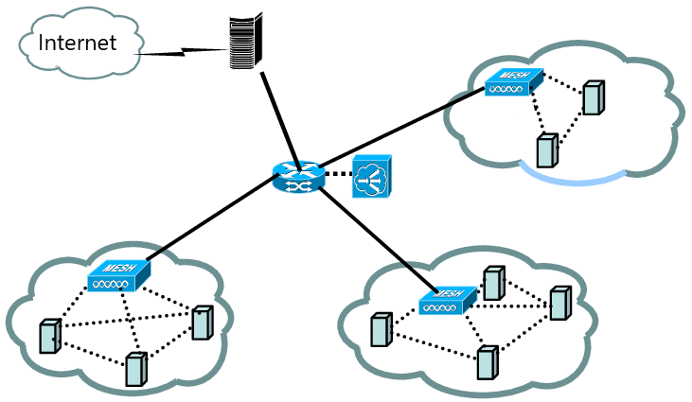

**Partial mesh topology**

**Advantages of Mesh topology:**

1. No data traffic issues as there is a dedicated link between two devices which means the link is only available for those two devices.
2. Mesh topology is reliable and robust as a failure of one link doesn’t affect the other links and the communication between other devices on the network.
3. Mesh topology is secure because there is a point to point link thus unauthorized access is not possible.
4. Fault detection is easy.

**Disadvantages of Mesh topology:**

1. The amount of wires required to connect each system is tedious(sıkıcı).
2. Since each device needs to be connected with other devices, the number of I/O ports required must be huge.
3. Scalability issues because a device cannot be connected with a large number of devices with a dedicated point to point link.

Q: What is mesh topology?  
A: Mesh topology is a setup wherein each device is connected directly to every other device on the network. Consequently, it requires that each device has at least two network connections.

- Interview Q&A

Q: What is one advantage of mesh topology?  
A: In the event that one link fails, there will always be another available. Mesh topology is actually one of the most fault-tolerant network topology.

- Interview Q&A

**Tree Topology**

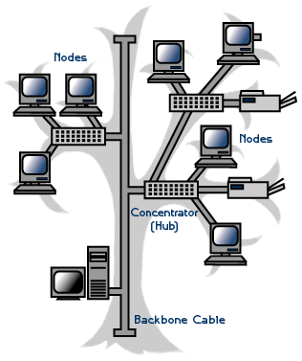A tree topology combines characteristics of linear bus and star topologies. It consists of groups of star-configured workstations connected to a linear bus backbone cable. Tree topologies allow for the expansion of an existing network.

**Advantages of tree topology:**  
1. It is scalable. Secondary nodes allow more devices to be connected to a central node.  
2. Point to point connection of devices.  
3. Having different levels of network makes it more manageable hence easier fault identification and isolation.

**Disadvantages of tree topology:**  
1. Maintenance of the network may be an issue when the network spans a great area.  
2. Since it is a variation of bus topology, if the backbone fails, the entire network is down.

**Point-to-Point Topology**

It's the simplest topology where there is a permanent link between two endpoints. These endpoints may be hubs, routers, switches, computers, etc. which give you one communication path. Switched point-to-point topologies are the basic model of conventional telephony.

* **Permanent (dedicated)**

Easiest to understand, the variations of point-to-point topology, is a point-to-point communications channel that appears, to the user, to be permanently associated with the two endpoints. A children’s tin can telephone is one example of a physical dedicated channel.

Within many switched telecommunications systems, it is possible to establish a permanent circuit. One example might be a telephone in the lobby of a public building, which is programmed to ring only the number of a telephone dispatcher. “Nailing down” a switched connection saves the cost of running a physical circuit between the two points. The resources in such a connection can be released when no longer needed.

* **Switched**

Using circuit-switching or packet-switching technologies, a point-to-point circuit can be set up dynamically and dropped when no longer needed. This is the basic model of conventional telephony.

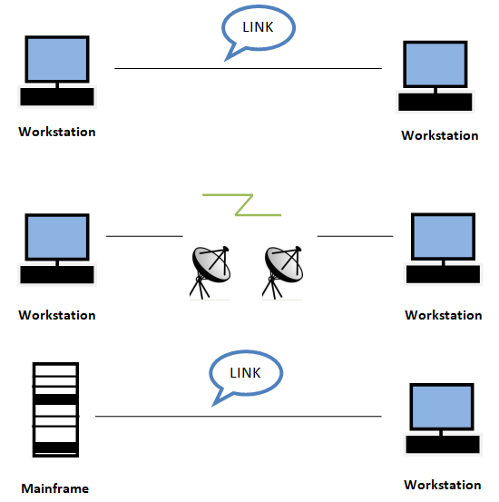

**Point-to-Multipoint Topology**

A **point-to-multipoint** topology consists of a succession of connections between an *interface* on one router and *multiple destination routers*—one point of connection to multiple points of connection. Each of the routers and every one of their interfaces involved in the point-to-multipoint connection is part of the same network.

The below figure shows another prime example of a point-to-multipoint network: a college or corporate campus.

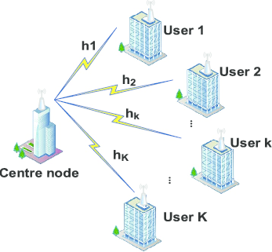

**Hybrid Topology**

**Hybrid topology** means just that—a combination of two or more types of physical or logical network topologies working together within the same network.

